reverside software solutions ltd



Table of Contents

**Document Properties** 3

**Version**3

**Overview**4

**Requirements Analysis**4

Technology Tools4

**Use Case Diagram**5

Figure 1.15

**Database Diagram**6

Figure 1.26

**Functional Requirement (Part 1)**7

Buyalot Web Application7

**Usage Scenarios**8

Customer Use Cases8

UC 1.08

UC 1.18

UC 1.29

UC 1.39

UC 1.410

UC 1.610

**Functional Requirement (Part 2)**11

Buyalot Web Application11

**Usage Scenarios**11

Administrator Use Cases11

UC 2.011

UC 2.112

UC 2.212

**Functional Requirement (Part 3)**13

Buyalot Web Application13

**Usage Scenarios**13

User Use Cases13

UC 3.013

**UI Template**14

# Document Properties

|  |  |
| --- | --- |
| Item | Details |
| Document Title: | Buyalot Replica |
| Author: | Sifiso Mazibuko |
| Create Date: | 2017-01-20 |

# Development Team

|  |
| --- |
| Name(s) |
| 1. Sifiso Mazibuko |
| 1. Tumelo Maremane |
| 1. Mojalefa Malatji |

# Version

|  |  |  |  |
| --- | --- | --- | --- |
| Version | Revision | Resource | Date |
| 1.0 | Buyalot Scope Meeting | Development Team | 2017-01-20 |
| 1.2 | ERD design | Development Team | 2017-01-23 |
|  | Implementation | Development Team | 2017-01-24 |

# Overview

This document details the Scope of the Functional Specification Requirements (FSR) for the Buyalot product. It includes high level integration and functionality requirements.

The information within the document was gathered through the scope meeting.

Requirement Analysis  
  
Technology Tools:

|  |  |
| --- | --- |
| 1. Software requirements | * Visual Studio 2015 Enterprise Edition (IDE) * ASP.NET MVC * Entity Framework * SQL Server 2014 Management Studio * AngularJs * JavaScript * Bootstrap * HTML5 & CSS3 * GITHUB |
| 1. Front-End | ASP.NET MVC , AngularJs, JavaScript, Bootstrap, HTML5 & CSS3 |
| 1. Back-End | SQL Server 2014 Management Studio, C# |

# Use Case Diagram

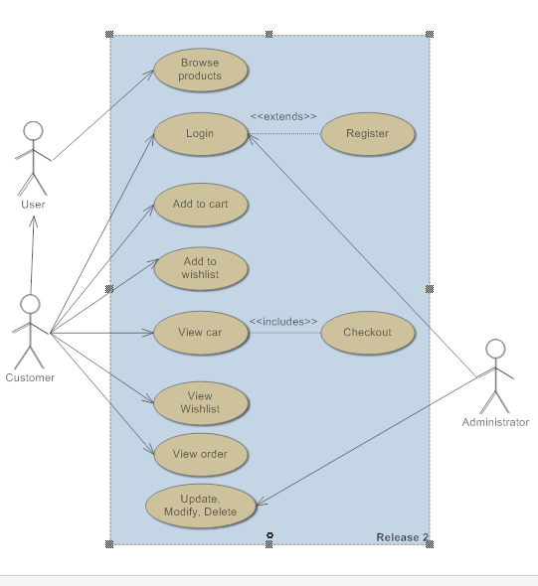

Figure 1.1 this diagram shows the actors that interact with the Buyalot system and the sequence of actions a system performs yielding visible results.

# Database Diagram

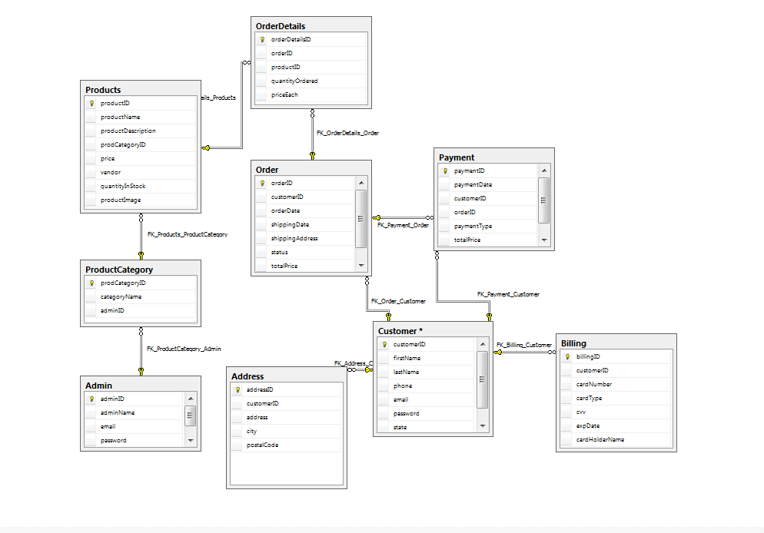

Figure 1.2 The table illustrate the entities and relationship between them.

# Functional Requirements (Part 1) Buyalot – Web Application

The following requirements have been identified for the solution.

Note: Numbering is used for traceability and not sequence.

|  |  |  |
| --- | --- | --- |
| Requirement Number | Requirement Name | Use Case Reference |
| Req#1 | **Requirement:**  Register to Buyalot | UC 1.0 |
| Req#2 | **Requirement:**  Login to Buyalot | UC 1.1 |
| Req#3 | **Requirement:**  User should be able to select category | UC 1.2 |
| Req#4 | **Requirement:**  User should be able to add selected products to cart | UC 1.3 |
| Req#5 | **Requirement:**  User should be able to add selected products to wish list | UC 1.4 |
| Req#6 | **Requirement:**  User should be able to checkout and pay for selected products | UC 1.5 |

# Usage Scenarios

The Usage scenarios describe the set of activities that the solution will address and support.  
Actions *(functions)  
Actors *(users in a specific situation)  
Paths *(moving from one state to the other)

# Customer Use Cases

**UC 1.0**

|  |  |  |  |
| --- | --- | --- | --- |
| Use Case ID | UC 1.0 | |  |
| Use Case: | Register to Buyalot | | |
| Notes: | Customer/User should register to use the Web application | | |
| Type: | Basic Path | | |
| Scenario: | Basic Path: |  | |
|  | Step | Action | |
|  | 1 | User completes the relevant information | |
|  | 2 | User clicks the register button | |
|  | 3 | Application display message, alerting the user for successful registration | |
| Type: | Alternative Path | | |
| Scenario: | Basic Path: |  | |
|  | Step |  | |
|  | 1 | Application display alerts for null or invalid data entered | |

**UC 1.1**

|  |  |  |  |
| --- | --- | --- | --- |
| Use Case ID | UC 1.0 | |  |
| Use Case: | Login to Buyalot | | |
| Notes: | User must be able login to use the Web application | | |
| Type: | Basic Path | | |
| Scenario: | Basic Path: |  | |
|  | Step | Action | |
|  | 1 | User enter the email and password | |
|  | 2 | User clicks the login button | |
|  | 3 | Application display message, alerting the user for successful login | |
| Type: | Alternative Path | | |
| Scenario: | Basic Path: |  | |
|  | Step |  | |
|  | 1 | Application display alerts for null or invalid data entered | |

**UC 1.2**

|  |  |  |  |
| --- | --- | --- | --- |
| Use Case ID | UC 1.2 | |  |
| Use Case: | Select category | | |
| Notes: | User should be able to select category for purchase of the product | | |
| Type: | Basic Path | | |
| Scenario: | Basic Path: |  | |
|  | Step | Action | |
|  | 1 | User clicks a category dropdown list, select category in dropdown | |
|  | 2 | User select product for purchase | |
|  | 3 | User clicks checkout button | |
|  | 4 | User select type of payment | |
| Type: | Alternative Path | | |
| Scenario: | Basic Path: |  | |
|  | Step |  | |
|  | 1 | Use “Search” option to search for product | |

**UC 1.3**

|  |  |  |  |
| --- | --- | --- | --- |
| Use Case ID | UC 1.3 | |  |
| Use Case: | Add products to cart | | |
| Notes: | User should be able to add selected products to cart | | |
| Type: | Basic Path | | |
| Scenario: | Basic Path: |  | |
|  | Step | Action | |
|  | 1 | User select product to add to cart | |
|  | 2 | User clicks the add to cart button | |
|  | 3 | User clicks the cart button, to view the products added to cart | |
|  |  |  | |
| Type: | Alternative Path | | |
| Scenario: | Basic Path: |  | |
|  | Step |  | |
|  | 1 | User Select product & clicks “Move to wish list” button | |
|  | 2 | User Select product & clicks “Remove/Delete” button to remove product from the cart | |

**UC 1.4**

|  |  |  |  |
| --- | --- | --- | --- |
| Use Case ID | UC 1.4 | |  |
| Use Case: | Add products to wish list | | |
| Notes: | User should be able to add selected products to wish list | | |
| Type: | Basic Path | | |
| Scenario: | Basic Path: |  | |
|  | Step | Action | |
|  | 1 | User select product to add to wish list | |
|  | 2 | User clicks the add to wish list button | |
|  | 3 | User clicks the wish list button, to view products added to wish list | |
| Type: | Alternative Path | | |
| Scenario: | Basic Path: |  | |
|  | Step |  | |
|  | 1 | User Select product & clicks “Move to cart” button | |
|  | 2 | User Select product & clicks “Remove/Delete” button to remove product from the wish list | |

**UC 1.5**

|  |  |  |  |
| --- | --- | --- | --- |
| Use Case ID | UC 1.5 | |  |
| Use Case: | Checkout | | |
| Notes: | User should be able to checkout and pay for selected products | | |
| Type: | Basic Path | | |
| Scenario: | Basic Path: |  | |
|  | Step | Action | |
|  | 1 | User select the product from selected category | |
|  | 2 | User clicks “Add to cart” button | |
|  | 3 | User clicks cart button | |
|  | 4 | User select one or more products added on the cart & clicks “checkout” button | |
|  | 5 | User select how he/she wants the product to be shipped (Courier/Collect) | |
|  | 6 | User select the type o payment (Credit/Debit/EFT) etc. | |
|  | 7 | User review & confirm order | |
| Type: | Alternative Path | | |
| Scenario: | Basic Path: |  | |
|  | Step |  | |
|  | 1 | User can click “cancel” button to discontinue the purchase | |

Functional Requirements (Part 2)   
Buyalot – Web Application

The following requirements have been identified for the solution.

Note: Numbering is used for traceability and not sequence.

|  |  |  |
| --- | --- | --- |
| Requirement Number | Requirement Name | Use Case Reference |
| Req#1 | **Requirement:**  Admin should Register to Buyalot web application | UC 2.0 |
| Req#2 | **Requirement:**  Admin should Login to Buyalot | UC 2.1 |
| Req#3 | **Requirement:**  Admin should be able to add, modify and delete the products in the system departments | UC 2.2 |

# Usage scenarios

The Usage scenarios describe the set of activities that the solution will address and support.  
Actions *(functions)   
Actors *(users in a specific situation)   
Paths *(moving from one state to the other)

# Administrator Use Cases

**UC 2.0**

|  |  |  |  |
| --- | --- | --- | --- |
| Use Case ID | UC 2.0 | |  |
| Use Case: | Register to Buyalot | | |
| Notes: | Admin should be able to register on the Web Application | | |
| Type: | Basic Path | | |
| Scenario: | Basic Path: |  | |
|  | Step | Action | |
|  | 1 | Admin complete the relevant information | |
|  | 2 | Admin clicks the register button | |
|  | 3 | Application display message, alerting the user for successful registration | |
| Type: | Alternative Path | | |
| Scenario: | Basic Path: |  | |
|  | Step |  | |
|  | 1 | Application display alerts for null or invalid data entered | |

**UC 2.1**

|  |  |  |  |
| --- | --- | --- | --- |
| Use Case ID | UC 2.0 | |  |
| Use Case: | Login to Buyalot | | |
| Notes: | Admin must be able securely login to use the Web application | | |
| Type: | Basic Path | | |
| Scenario: | Basic Path: |  | |
|  | Step | Action | |
|  | 1 | User enter the email and password | |
|  | 2 | User clicks the login button | |
|  | 3 | Application display message, alerting the user for successful login | |
| Type: | Alternative Path | | |
| Scenario: | Basic Path: |  | |
|  | Step |  | |
|  | 1 | Application display alerts for null or invalid data entered | |

**UC 2.2**

|  |  |  |  |
| --- | --- | --- | --- |
| Use Case ID | UC 2.2 | |  |
| Use Case: | Add, modify, update or delete | | |
| Notes: | Admin should be able to add, modify and delete the products in the system departments | | |
| Type: | Basic Path | | |
| Scenario: | Basic Path: |  | |
|  | Step | Action | |
|  | 1 | Admin login to the Web application | |
|  | 2 | Admin select product category | |
|  | 3 | Admin choose to Add, Modify, Update or Delete the products/ product category | |

Functional Requirements (Part 3)   
Buyalot – Web Application

The following requirements have been identified for the solution.

Note: Numbering is used for traceability and not sequence.

|  |  |  |
| --- | --- | --- |
| Requirement Number | Requirement Name | Use Case Reference |
| Req#1 | **Requirement:**  User Should be able to browser the Buyalot | UC 3.0 |

# Usage scenarios

The Usage scenarios describe the set of activities that the solution will address and support.  
Actions *(functions)   
Actors *(users in a specific situation)   
Paths *(moving from one state to the other)

**UC 3.0**

|  |  |  |  |
| --- | --- | --- | --- |
| Use Case ID | UC 3.0 | |  |
| Use Case: | Browse for Products | | |
| Notes: | User should be able to browse for products | | |
| Type: | Basic Path | | |
| Scenario: | Basic Path: |  | |
|  | Step | Action | |
|  | 1 | Enter the URL of Buyalot Web application | |
|  | 2 | Select Product by category through dropdown | |
|  | 3 | Browse the available category | |

# UI Template

Figure 1.3 Index Page

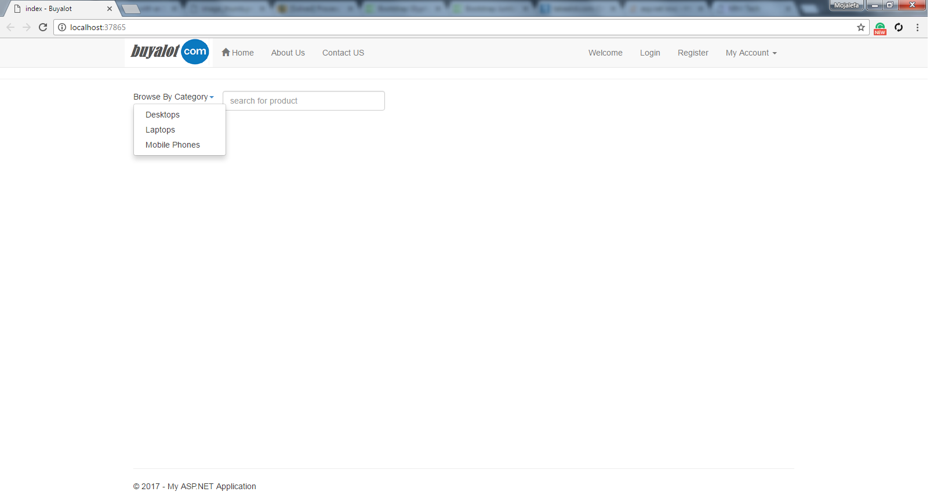Figure 1.4 Index Page

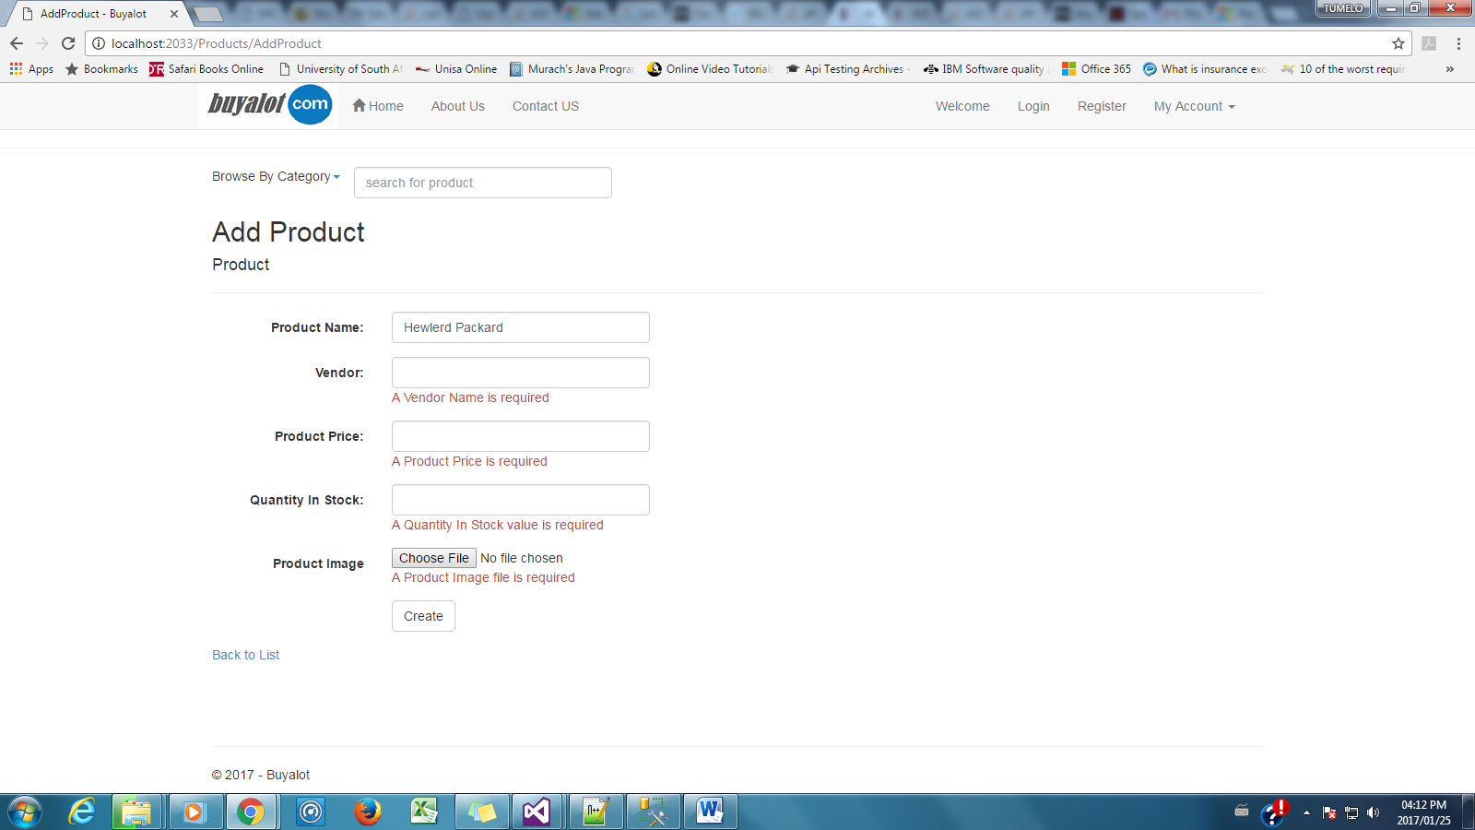

Figure 1.5 Add Products

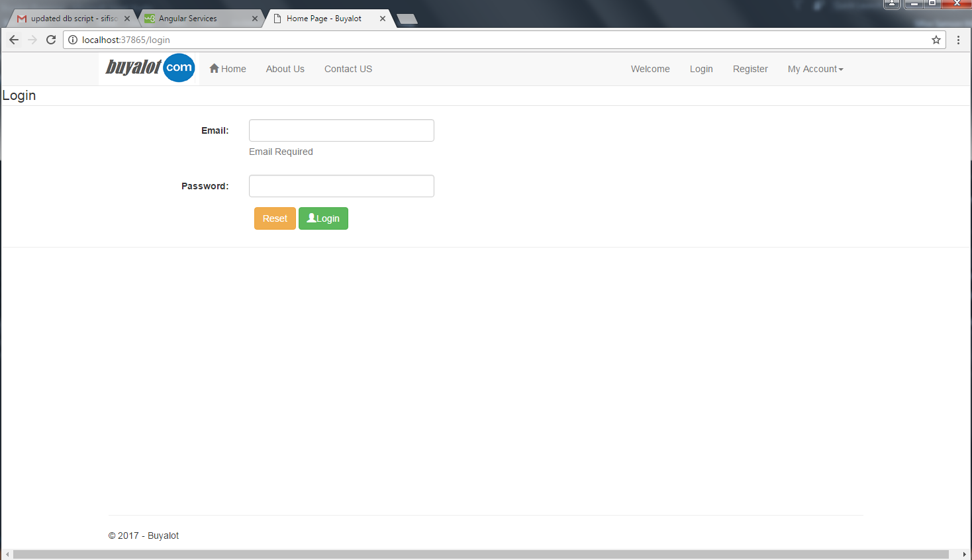

Figure 1.6 Login Page

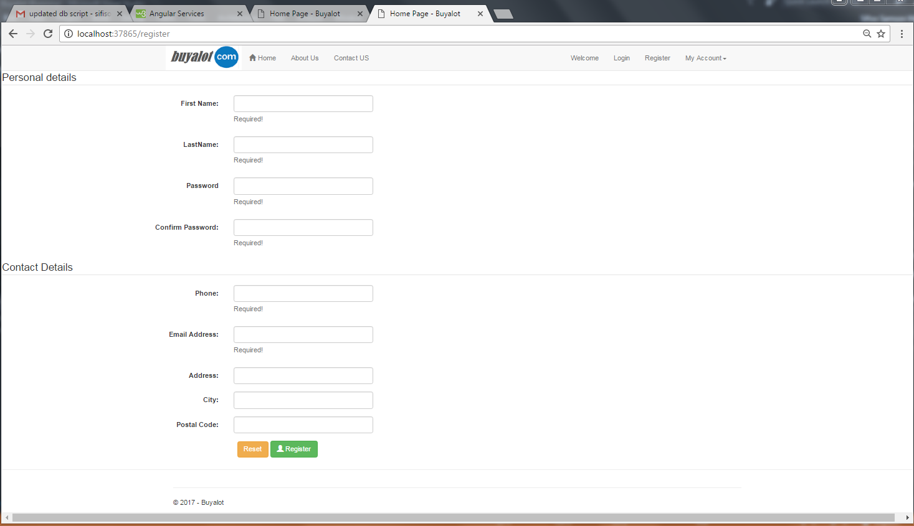

Figure 1.7 Register Page

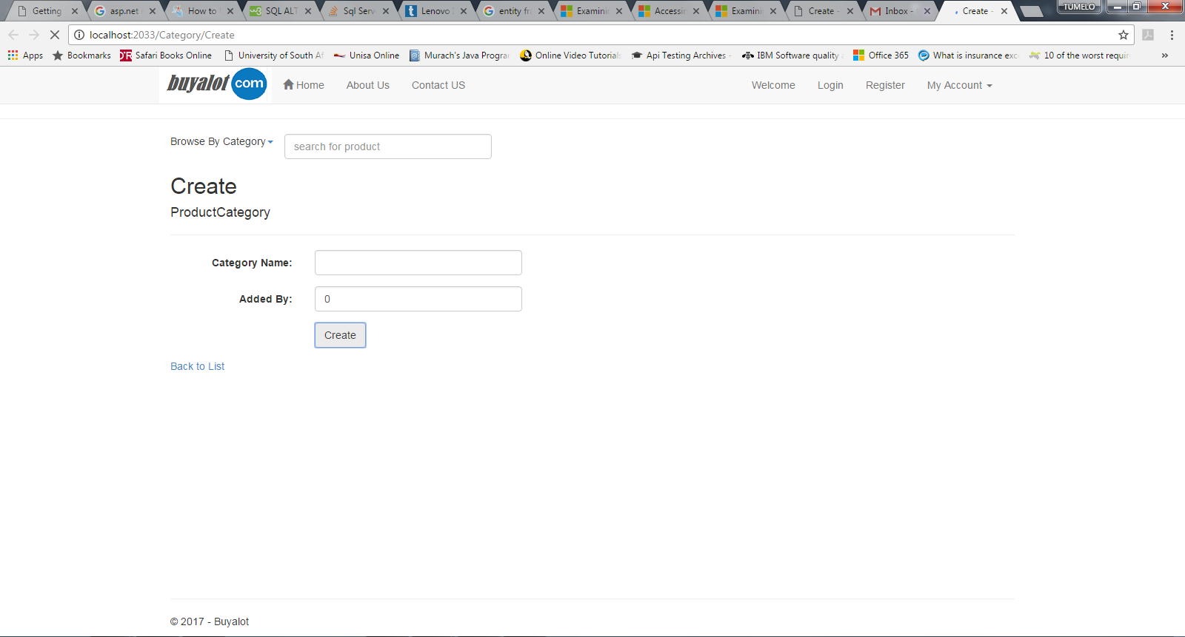

Figure 1.7 Create Category

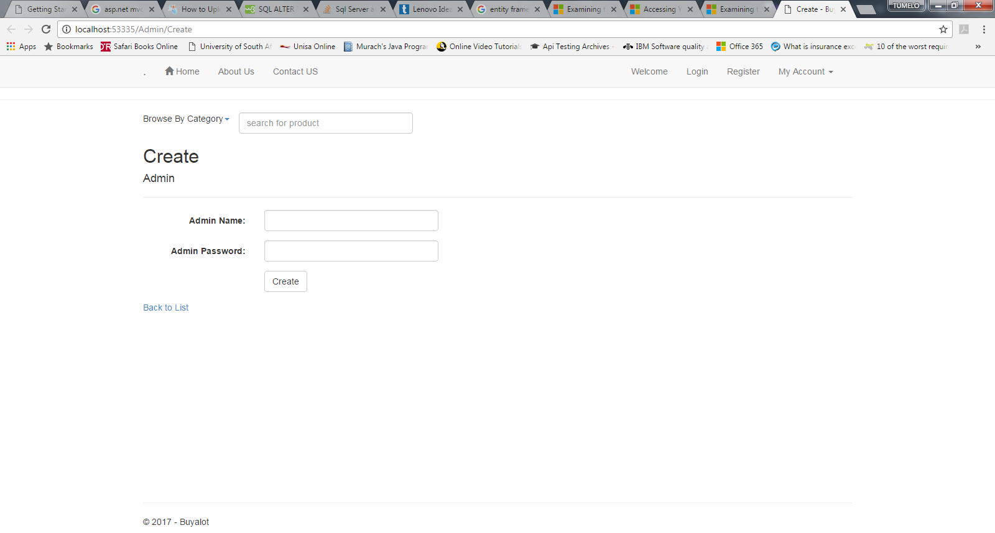

Figure 1.8 Create Admin

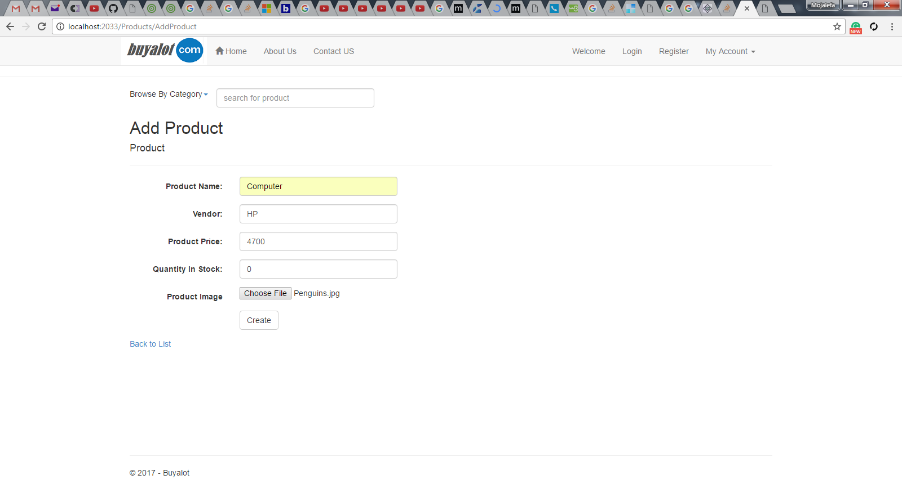

Figure 1.9 Add Products

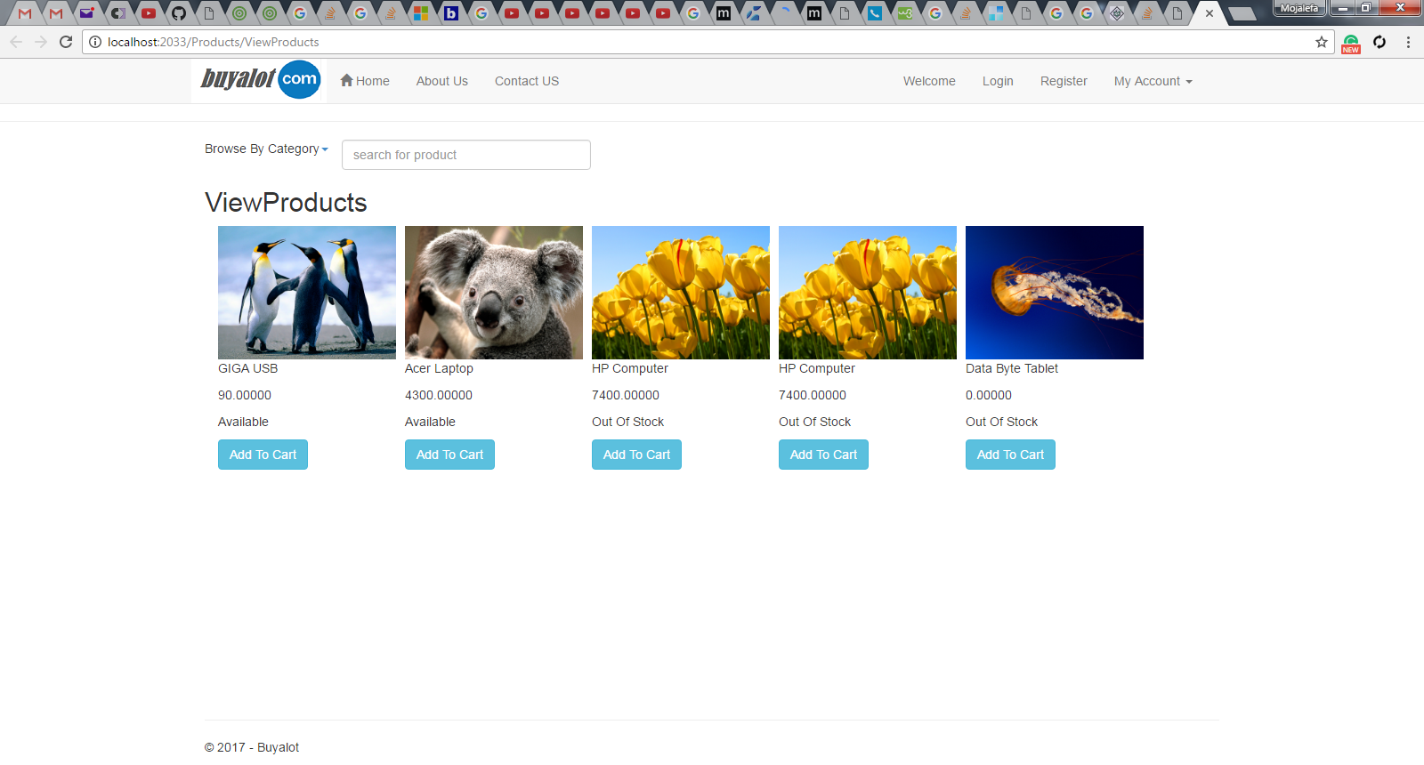

Figure 1.10 Display added products

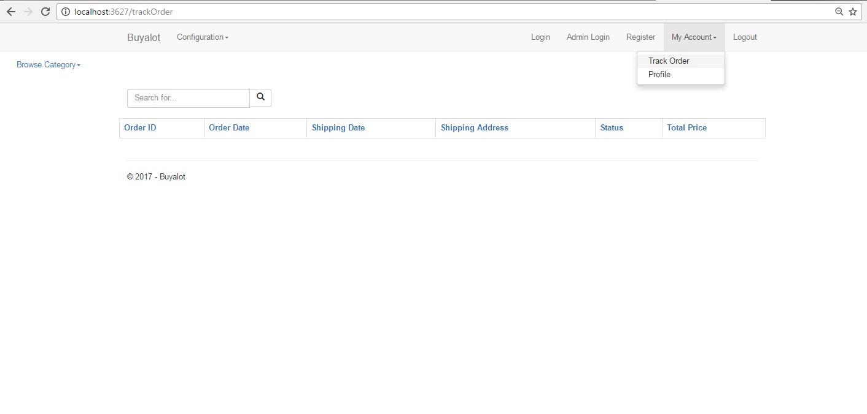

Figure 1.11 Track Order history

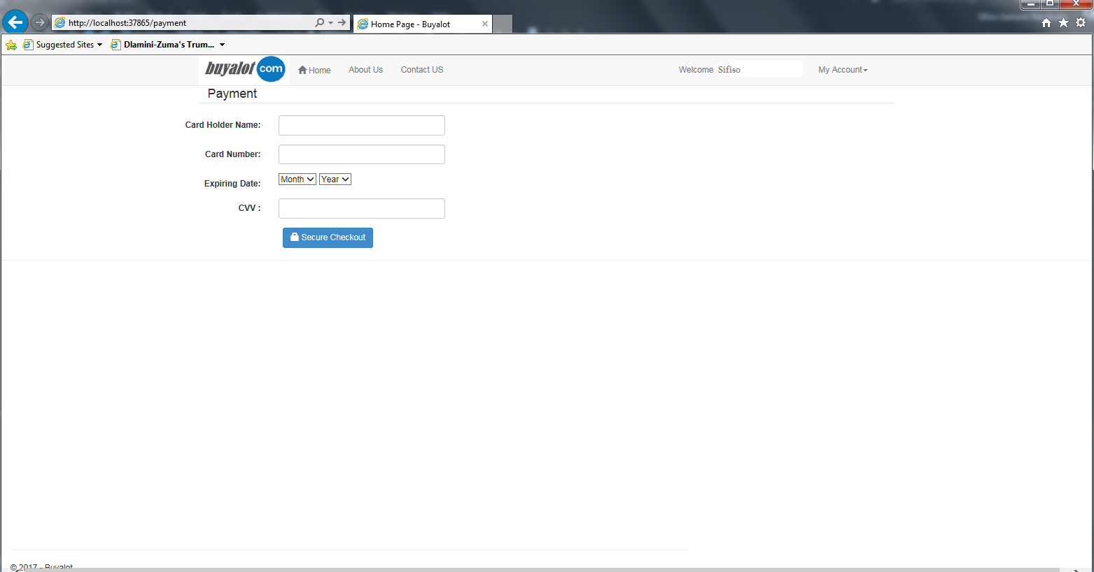

Figure 1.12 Pay for products purchased

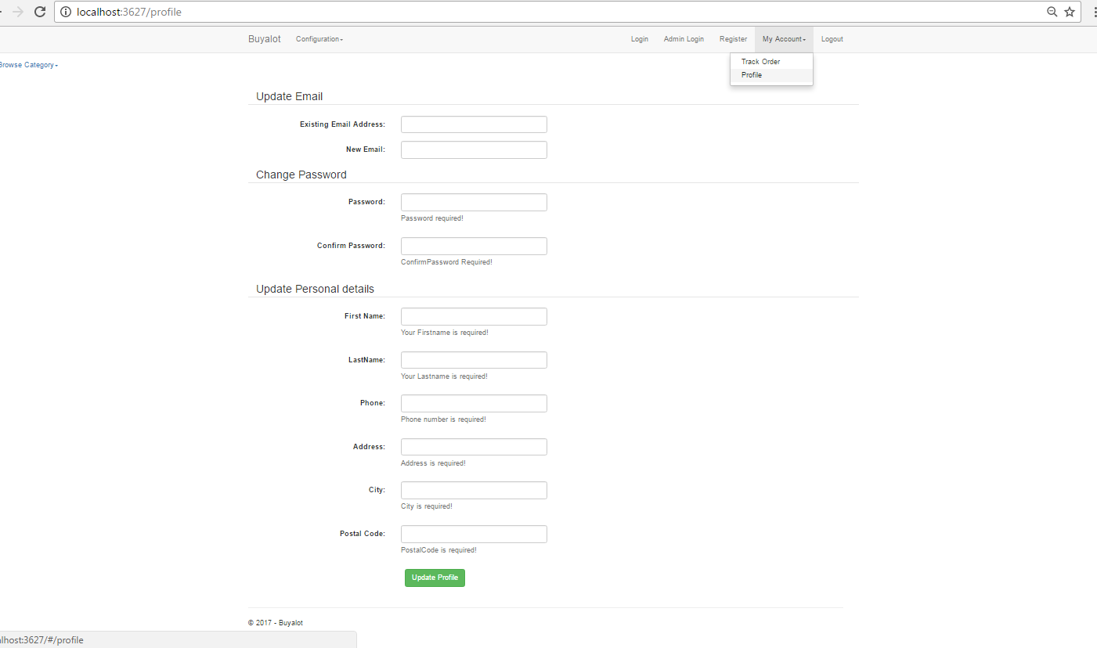

Figure 1.13 Update Profile

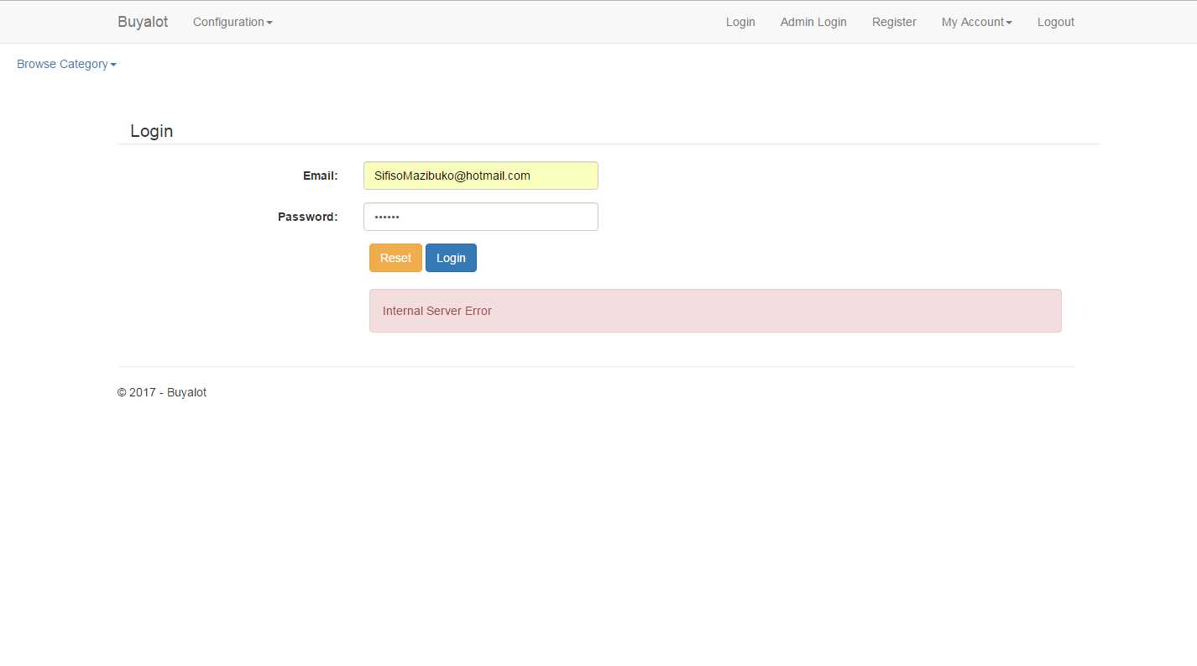

Figure 1.13 Validation Login User doesn’t exists

